**Failure Rate**

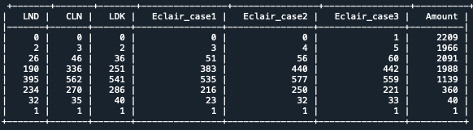

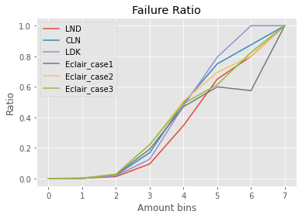

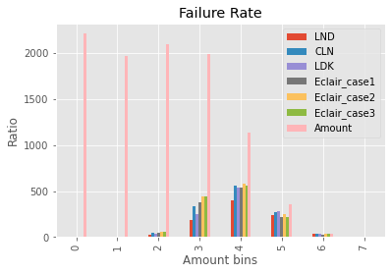

**Success Rate**

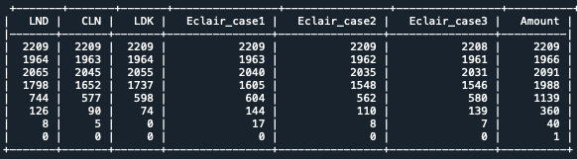

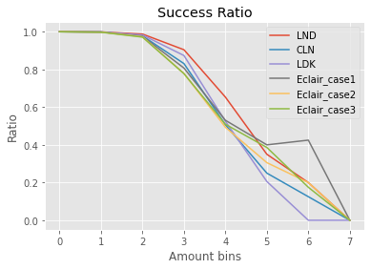

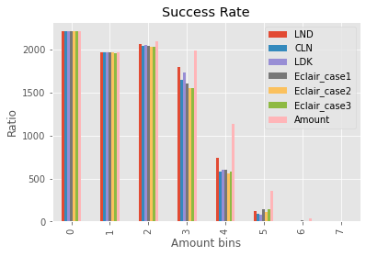

**Success Rate (scaled to 100)**

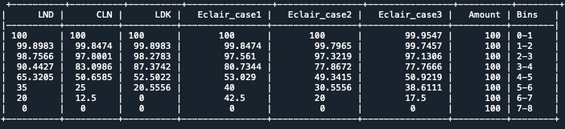

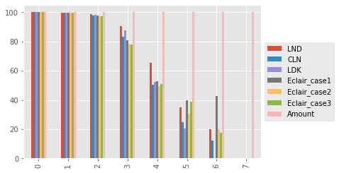

**Fee vs Amount**

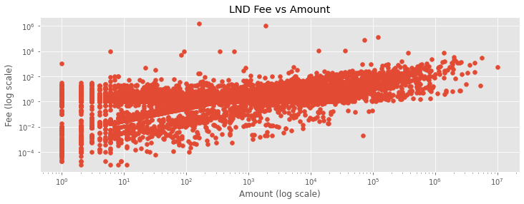

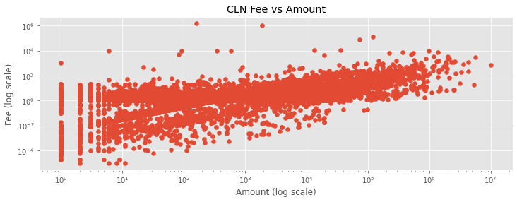

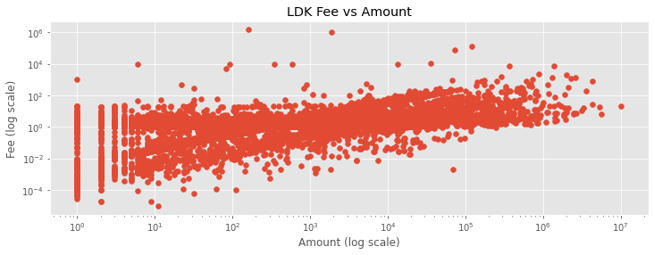

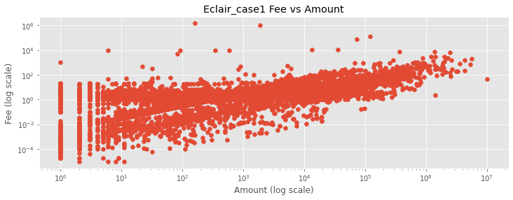

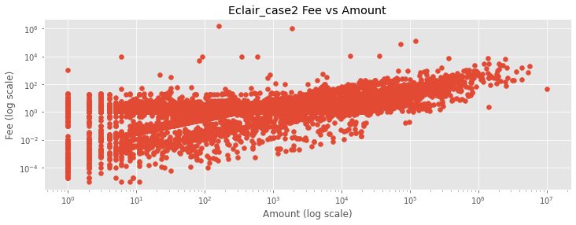

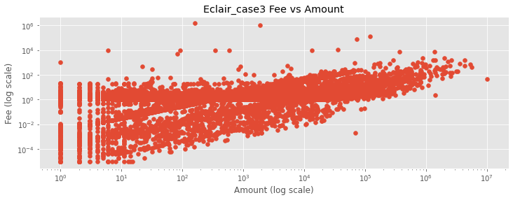

**Path length**

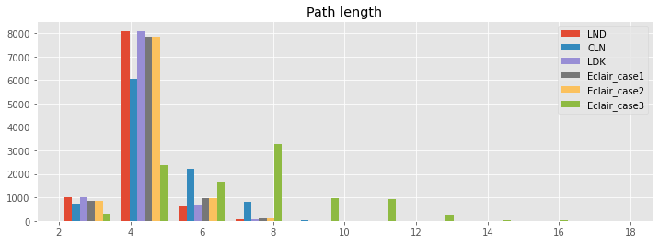

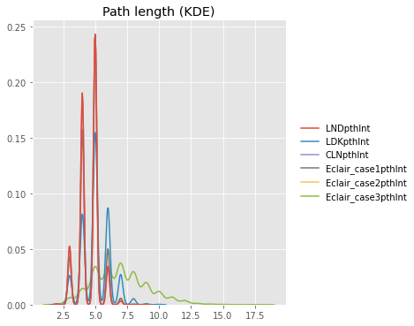

|  |  |
| --- | --- |
|  | **Mean Path length** |
| LND | 4.510925056156831 |
| CLN | 4.519808045742291 |
| LDK | 5.070247090055136 |
| Eclair_case1 | 4.636001633653257 |
| Eclair_case2 | 4.636001633653257 |
| Eclair_case3 | 6.962323871758219 |

**Delay**

